CAT C: JAVA SWING

C1-Write a program which takes name and age from the user on click of the button and display a message on label, user is eligible to vote or not.

**Code:**

import java.awt.EventQueue;

import javax.swing.JFrame;

import javax.swing.JPanel;

import javax.swing.border.EmptyBorder;

import javax.swing.JLabel;

import javax.swing.JTextField;

import javax.swing.JButton;

import java.awt.Font;

import java.awt.Color;

public class Vote extends JFrame {

private JPanel contentPane;

private JTextField textField;

private JTextField T2;

/**

* Launch the application.

*/

public static void main(String[] args) {

EventQueue.invokeLater(new Runnable() {

public void run() {

try {

Vote frame = new Vote();

frame.setVisible(true);

} catch (Exception e) {

e.printStackTrace();

}

}

});

}

/**

* Create the frame.

*/

public Vote() {

setDefaultCloseOperation(JFrame.EXIT_ON_CLOSE);

setBounds(100, 100, 450, 300);

contentPane = new JPanel();

contentPane.setBackground(Color.PINK);

contentPane.setBorder(new EmptyBorder(5, 5, 5, 5));

setContentPane(contentPane);

contentPane.setLayout(null);

JLabel lblNewLabel = new JLabel("Enter Name");

lblNewLabel.setFont(new Font("Times New Roman", Font.BOLD, 12));

lblNewLabel.setBounds(69, 73, 72, 17);

contentPane.add(lblNewLabel);

JLabel lblNewLabel_1 = new JLabel("Enter Age");

lblNewLabel_1.setFont(new Font("Times New Roman", Font.BOLD, 12));

lblNewLabel_1.setBounds(69, 125, 72, 14);

contentPane.add(lblNewLabel_1);

textField = new JTextField();

textField.setBounds(186, 71, 86, 20);

contentPane.add(textField);

textField.setColumns(10);

T2 = new JTextField();

T2.setBounds(186, 122, 86, 20);

contentPane.add(T2);

T2.setColumns(10);

JButton btnNewButton = new JButton("SUBMIT");

btnNewButton.setBackground(Color.RED);

btnNewButton.setBounds(63, 184, 89, 23);

contentPane.add(btnNewButton);

JButton T1 = new JButton("New button");

T1.setBounds(183, 184, 89, 23);

contentPane.add(T1);

}

}

**Output:**

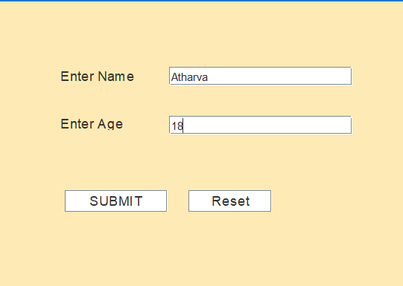

C2- Write a program to create two textfield and four radiobuttons (+,-,*,%)and on selecting the radiobutton the operation should be performed and result should be displayed in JOptionPane.

**Code:**

import java.awt.EventQueue;

import javax.swing.JFrame;

import javax.swing.JPanel;

import javax.swing.border.EmptyBorder;

import javax.swing.JTextField;

import javax.swing.JLabel;

import javax.swing.JOptionPane;

import javax.swing.JRadioButton;

import java.awt.Font;

import javax.swing.ButtonGroup;

import java.awt.event.ActionListener;

import java.awt.event.ActionEvent;

public class Operation extends JFrame {

private JPanel contentPane;

private JTextField l1;

private JTextField l2;

private final ButtonGroup buttonGroup = new ButtonGroup();

double n1,n2;

void input() {

n1=Double.parseDouble(l1.getText());

n2=Double.parseDouble(l2.getText());

}

/**

* Launch the application.

*/

public static void main(String[] args) {

EventQueue.invokeLater(new Runnable() {

public void run() {

try {

Operation frame = new Operation();

frame.setVisible(true);

} catch (Exception e) {

e.printStackTrace();

}

}

});

}

/**

* Create the frame.

*/

public Operation() {

setTitle("2nd _ Cal");

setDefaultCloseOperation(JFrame.EXIT_ON_CLOSE);

setBounds(100, 100, 450, 300);

contentPane = new JPanel();

contentPane.setBorder(new EmptyBorder(5, 5, 5, 5));

setContentPane(contentPane);

contentPane.setLayout(null);

l1 = new JTextField();

l1.setBounds(186, 30, 132, 20);

contentPane.add(l1);

l1.setColumns(10);

l2 = new JTextField();

l2.setBounds(186, 84, 132, 20);

contentPane.add(l2);

l2.setColumns(10);

JLabel lblNewLabel = new JLabel("Enter 1st no.");

lblNewLabel.setFont(new Font("Times New Roman", Font.BOLD, 14));

lblNewLabel.setBounds(32, 30, 114, 17);

contentPane.add(lblNewLabel);

JLabel lblNewLabel_1 = new JLabel("Enter 2nd no.");

lblNewLabel_1.setFont(new Font("Times New Roman", Font.BOLD, 14));

lblNewLabel_1.setBounds(32, 84, 114, 17);

contentPane.add(lblNewLabel_1);

JRadioButton r2 = new JRadioButton("Sub (-)");

r2.addActionListener(new ActionListener() {

public void actionPerformed(ActionEvent e) {

input();

JOptionPane.showMessageDialog(r2,"Subtraction is "+(n1-n2));

}

});

buttonGroup.add(r2);

r2.setBounds(209, 142, 109, 23);

contentPane.add(r2);

JRadioButton r4 = new JRadioButton("Div (-)");

r4.addActionListener(new ActionListener() {

public void actionPerformed(ActionEvent e) {

input();

JOptionPane.showMessageDialog(r4,"Division is "+(n1/n2));

}

});

buttonGroup.add(r4);

r4.setBounds(209, 188, 109, 23);

contentPane.add(r4);

JRadioButton r1 = new JRadioButton("Add (+)");

r1.addActionListener(new ActionListener() {

public void actionPerformed(ActionEvent e) {

input();

JOptionPane.showMessageDialog(r1,"Addition is "+(n1+n2));

}

});

buttonGroup.add(r1);

r1.setBounds(32, 142, 109, 23);

contentPane.add(r1);

JRadioButton r3 = new JRadioButton("Mul (*)");

r3.addActionListener(new ActionListener() {

public void actionPerformed(ActionEvent e) {

input();

JOptionPane.showMessageDialog(r3,"Multiplication is "+(n1*n2));

}

});

buttonGroup.add(r3);

r3.setBounds(32, 188, 109, 23);

contentPane.add(r3);

}

}

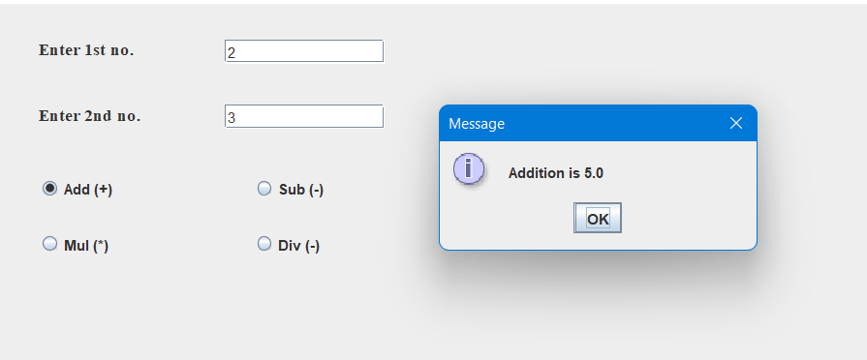

C3-  Write a program that creates a list containing ice-cream flavours.  On selection of any flavour price should be displayed in text field.

**Code:**

import java.awt.EventQueue;

import javax.swing.JFrame;

import javax.swing.JPanel;

import javax.swing.border.EmptyBorder;

import javax.swing.JList;

import javax.swing.AbstractListModel;

import javax.swing.JTextField;

import javax.swing.ListSelectionModel;

import javax.swing.event.ListSelectionListener;

import javax.swing.event.ListSelectionEvent;

public class IceCream extends JFrame {

private JPanel contentPane;

private JTextField t1;

/**

* Launch the application.

*/

public static void main(String[] args) {

EventQueue.invokeLater(new Runnable() {

public void run() {

try {

IceCream frame = new IceCream();

frame.setVisible(true);

} catch (Exception e) {

e.printStackTrace();

}

}

});

}

/**

* Create the frame.

*/

public IceCream() {

setDefaultCloseOperation(JFrame.EXIT_ON_CLOSE);

setBounds(100, 100, 450, 300);

contentPane = new JPanel();

contentPane.setBorder(new EmptyBorder(5, 5, 5, 5));

setContentPane(contentPane);

contentPane.setLayout(null);

JList list = new JList();

list.addListSelectionListener(new ListSelectionListener() {

public void valueChanged(ListSelectionEvent e) {

int i=list.getSelectedIndex();

if(i==1) {

t1.setText("Price of "+list.getSelectedValue()+" is 20");

}

else if(i==2) {

t1.setText("Price of "+list.getSelectedValue()+" is 30");

}

else if(i==3 ) {

t1.setText("Price of "+list.getSelectedValue()+" is 30");

}

else if(i==4) {

t1.setText("Price of "+list.getSelectedValue()+" is 40");

}

}

});

list.setSelectionMode(ListSelectionModel.SINGLE_INTERVAL_SELECTION);

list.setModel(new AbstractListModel() {

String[] values = new String[] {"Select your flavour", "Vanilla", "Strawberry", "Chocolate", "Mango"};

public int getSize() {

return values.length;

}

public Object getElementAt(int index) {

return values[index];

}

});

list.setBounds(34, 11, 214, 142);

contentPane.add(list);

t1 = new JTextField();

t1.setEditable(false);

t1.setBounds(34, 187, 254, 29);

contentPane.add(t1);

t1.setColumns(10);

}

}

**Output:**

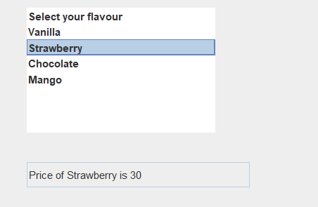

C4-  Write a program to create a Combobox, textfield and button and on click of button the value of textfield should be added to combobox.

**Code:**

import java.awt.EventQueue;

import javax.swing.JFrame;

import javax.swing.JPanel;

import javax.swing.border.EmptyBorder;

import javax.swing.JComboBox;

import javax.swing.JTextField;

import javax.swing.JButton;

import javax.swing.JList;

import java.awt.event.ActionListener;

import java.awt.event.ActionEvent;

public class ComboBox extends JFrame {

private JPanel contentPane;

private JTextField t1;

/**

* Launch the application.

*/

public static void main(String[] args) {

EventQueue.invokeLater(new Runnable() {

public void run() {

try {

ComboBox frame = new ComboBox();

frame.setVisible(true);

} catch (Exception e) {

e.printStackTrace();

}

}

});

}

/**

* Create the frame.

*/

public ComboBox() {

setDefaultCloseOperation(JFrame.EXIT_ON_CLOSE);

setBounds(100, 100, 450, 300);

contentPane = new JPanel();

contentPane.setBorder(new EmptyBorder(5, 5, 5, 5));

setContentPane(contentPane);

contentPane.setLayout(null);

JComboBox jc1 = new JComboBox();

jc1.setBounds(198, 76, 226, 100);

contentPane.add(jc1);

t1 = new JTextField();

t1.setText("Add");

t1.setBounds(143, 45, 86, 20);

contentPane.add(t1);

t1.setColumns(10);

JList list = new JList();

list.setBounds(29, 76, 1, 1);

contentPane.add(list);

JButton b1 = new JButton(" Add Anything");

b1.addActionListener(new ActionListener() {

public void actionPerformed(ActionEvent e) {

jc1.addItem(t1.getText());

t1.setText("");

}

});

b1.setBounds(0, 92, 89, 23);

contentPane.add(b1);

}

}

**Output:**

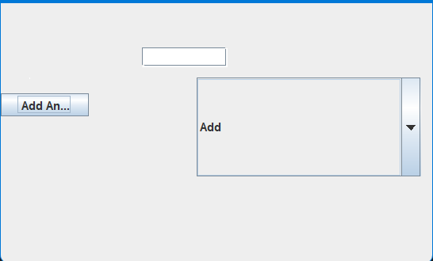

C5- Create an application where user can place order for pizza.  Accept user-name, address, mobile- no from user.  Give options for 4 types of pizza (basic, thick & chewy, thin & crispy, Chicago deep dish). Also provide options for multiple toppings (Pepperoni, sausage, black olives, and mushrooms).  Confirm the order by displaying all the details in a JOptionPane.

**Code:**

import java.awt.EventQueue;

import javax.swing.JFrame;

import javax.swing.JPanel;

import javax.swing.border.EmptyBorder;

import javax.swing.JLabel;

import javax.swing.JTextField;

import javax.swing.JTextArea;

import javax.swing.JComboBox;

import javax.swing.DefaultComboBoxModel;

import javax.swing.JList;

import javax.swing.JOptionPane;

import javax.swing.AbstractListModel;

import javax.swing.JButton;

import java.awt.event.ActionListener;

import java.awt.event.ActionEvent;

public class Pizza extends JFrame {

private JPanel contentPane;

JTextField t1;

JTextArea t2;

JTextField t3;

JComboBox t4;

JList t5;

/**

* Launch the application.

*/

public static void main(String[] args) {

EventQueue.invokeLater(new Runnable() {

public void run() {

try {

Pizza frame = new Pizza();

frame.setVisible(true);

} catch (Exception e) {

e.printStackTrace();

}

}

});

}

/**

* Create the frame.

*/

public Pizza() {

setDefaultCloseOperation(JFrame.EXIT_ON_CLOSE);

setBounds(100, 100, 450, 300);

contentPane = new JPanel();

contentPane.setBorder(new EmptyBorder(5, 5, 5, 5));

setContentPane(contentPane);

contentPane.setLayout(null);

JLabel l1 = new JLabel("User Name : ");

l1.setBounds(10, 11, 141, 26);

contentPane.add(l1);

JLabel l2 = new JLabel("Address : ");

l2.setBounds(8, 48, 116, 26);

contentPane.add(l2);

JLabel l3 = new JLabel("Mobile No. : ");

l3.setBounds(10, 102, 100, 34);

contentPane.add(l3);

JLabel l4 = new JLabel("Base :");

l4.setBounds(10, 144, 60, 26);

contentPane.add(l4);

JLabel l5 = new JLabel("Topping : ");

l5.setBounds(10, 181, 62, 26);

contentPane.add(l5);

t1 = new JTextField();

t1.setBounds(80, 14, 233, 20);

contentPane.add(t1);

t1.setColumns(10);

t2 = new JTextArea();

t2.setBounds(80, 49, 261, 52);

contentPane.add(t2);

t3 = new JTextField();

t3.setBounds(81, 109, 260, 20);

contentPane.add(t3);

t3.setColumns(10);

t4 = new JComboBox();

t4.setModel(new DefaultComboBoxModel(new String[] {"Select your Pizza Base", "Basic ", "Thick & Chewy", "Thin & Crispy", "Chicago Deep Dish"}));

t4.setBounds(80, 140, 261, 20);

contentPane.add(t4);

t5 = new JList();

t5.setModel(new AbstractListModel() {

String[] values = new String[] {"Select your Pizza Toppings", "Pepperoni", "Sausage", "Black Olives", "Mushrooms"};

public int getSize() {

return values.length;

}

public Object getElementAt(int index) {

return values[index];

}

});

t5.setBounds(82, 163, 261, 64);

contentPane.add(t5);

JButton btnNewButton = new JButton("Reset");

btnNewButton.addActionListener(new ActionListener() {

public void actionPerformed(ActionEvent e) {

t1.setText("");

t2.setText("");

t3.setText("");

t4.setSelectedIndex(0);

t5.setSelectedIndex(0); }

});

btnNewButton.setBounds(10, 227, 89, 23);

contentPane.add(btnNewButton);

JButton b3 = new JButton("Order");

b3.addActionListener(new ActionListener() {

public void actionPerformed(ActionEvent e) {

String msg=t1.getText()+"Your details are: \n";

msg += "Address: "+t2.getText()+"\n Mobile: "+t2.getText();

msg += "\n pizza Base: "+t4.getSelectedItem();

String str=" ";

Object obj[]=t5.getSelectedValues();

for(int i=0;i<obj.length;i++)

str+=obj[i]+",";

msg+="\n Toppings: "+str+"\n Your Order will reach soon......";

JOptionPane.showMessageDialog(b3,msg);

}

});

b3.setBounds(124, 227, 89, 23);

contentPane.add(b3);

}

}

**Output:**

